IQ – Do you know normalize space in Xpath

**normalize-space** is a function in XPath which ignores all redundant spaces in a target string HTML element and and returns the resulting string. Here redundant space means:

1. Leading Space
2. Trailing Space
3. Repeated White Space (replaces sequences of whitespace characters by a single space)

Also, it Removes all new lines and tabs present in a string

Practice WebSite

<http://autopract.com/selenium/normalize.html>

Normalize-space with text() function

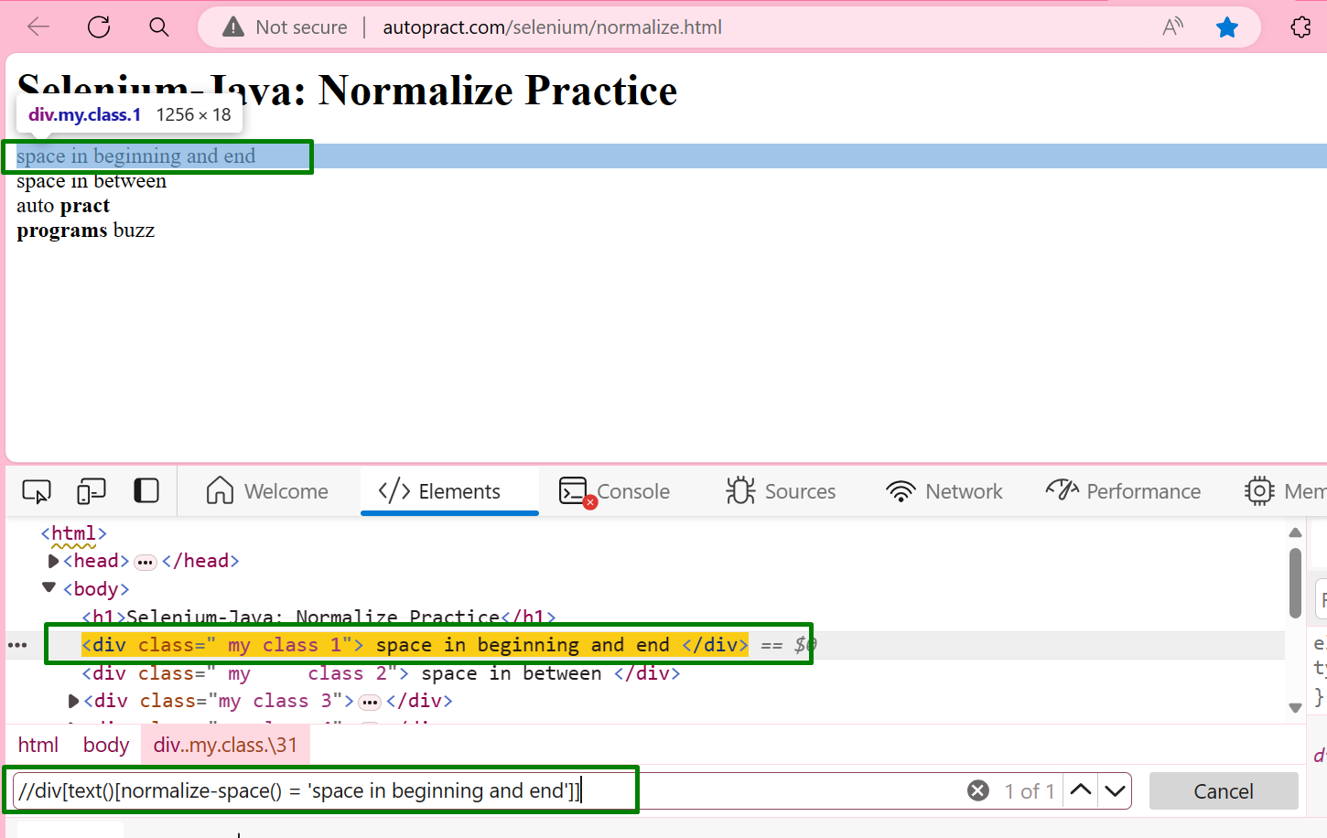

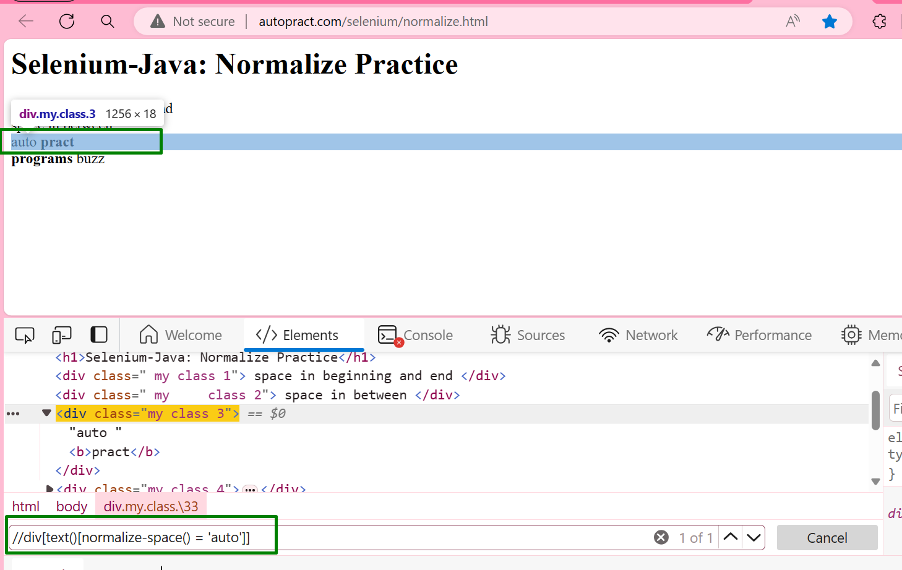

## Normalize-space with contains() function

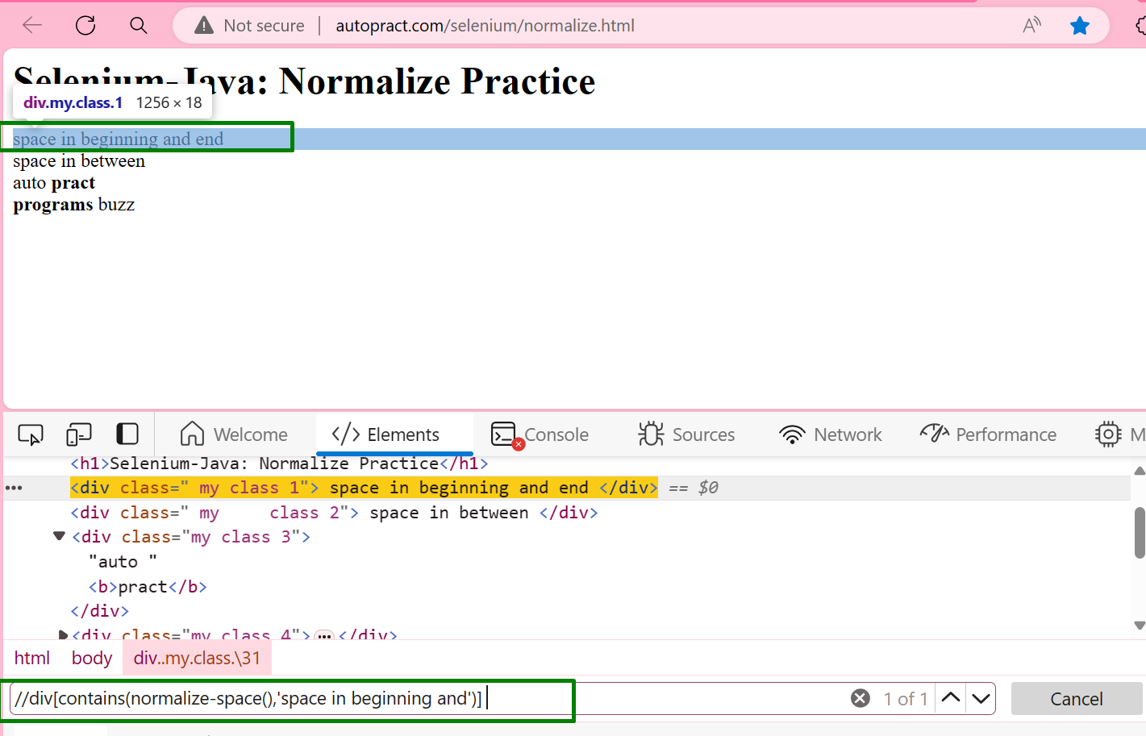

## Normalize-space with attribute

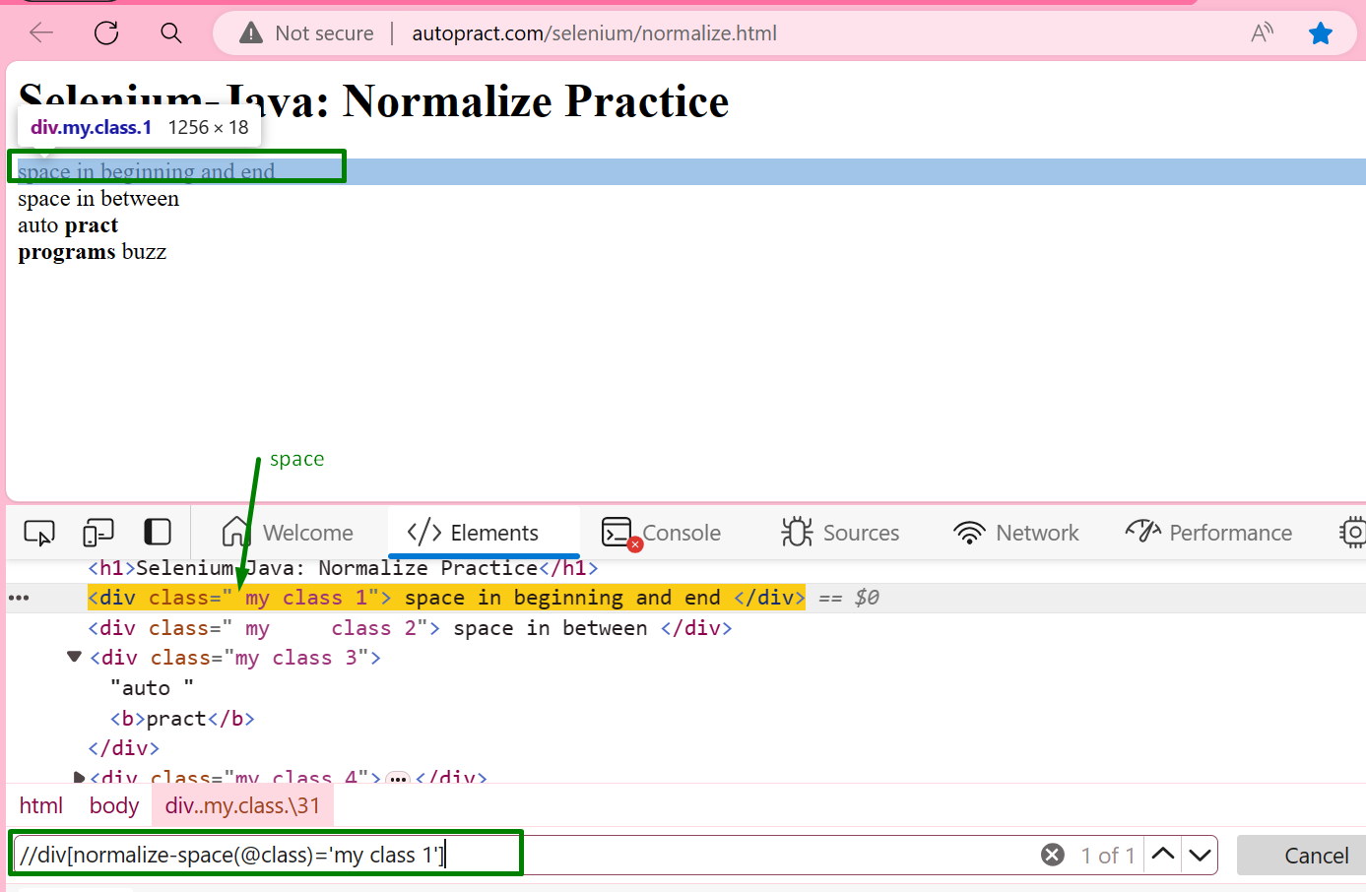

**Reference Website**

<https://www.programsbuzz.com/article/normalize-space-xpath-selenium>